 ***Faculty of Computing & Information Technology***

**CC-215-L: Database Systems Lab**

**BSCS Morning - Fall 2022, Semester Spring 2024**

**LAB – 02**

**Course & Lab Instructor:** Sanam Ahmad.

***Allowed time: 90 mins.***

**Topics:**

1. SQL operators **(Like, IsNULL, In, Between)**
2. Single Row Functions (**Date_Format(), Concat(), Substr(), Instr(), IfNull(), IF()**)

***Instructions:***

1. Gossips are not allowed.
2. Teacher assistants are for your help, so be nice with them. Respect them as they are teaching you. Raise your hands if you have some problem and need help from TA. Avoid calling them by raising your voice and disturbing the environment of Lab.
3. TA may deduct your marks for any kind of ill-discipline or misconduct from your side.
4. Evaluation will be considered final and you cannot debate for the marks. So, focus on performing the tasks when the time is given to you.
5. Paste the query as well as result table screenshot as a result of each task

**Task 01: (7 Marks)**

1. Retrive all Employees whose name starts with B (use of Like operator is not allowed)

1. Display Employee information whose NAME length is 5. (Use of **Length** function is not allowed).

1. Write an SQL query that contains Letter ‘L’ on second position and ends with ‘E’ in employees’ names**. (Use Like operator only)**

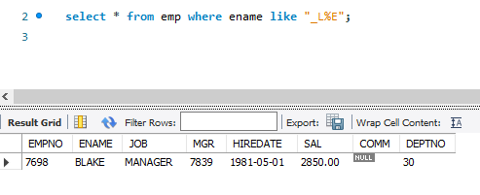

1. Adds three dollar signs ($$$) at the beginning and the end of a string.In the middle, includes the last three characters of the employee's name and their employee number.

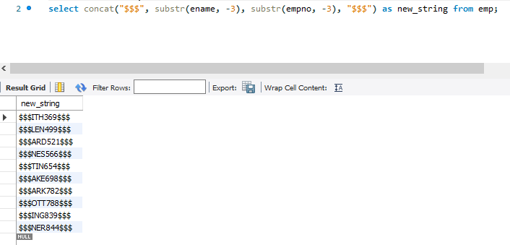

1. Find the employees that are hired after the 1981 and before the 1987

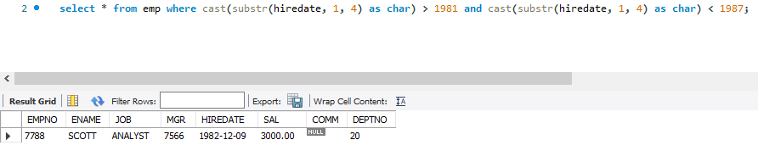

1. Retrieves the employee’s name along with the number of days, weeks, and years since they were hired

**Note:**  **DATEDIFF(CURDATE(), HIREDATE) used this to calculate days.**

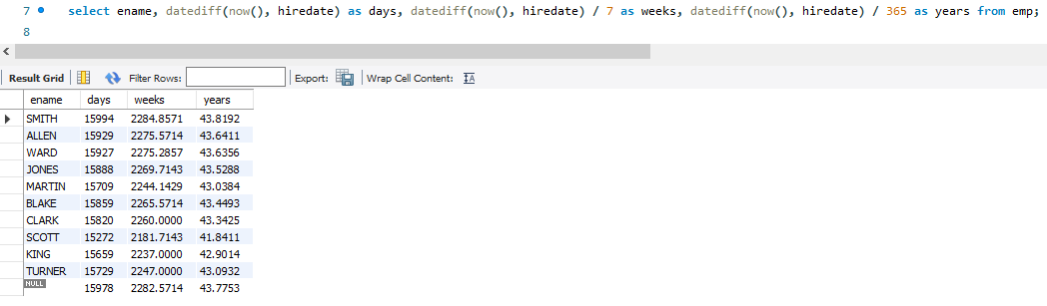

1. Check if the salary is 0 and display ‘No Salary’ if it is, otherwise return the actual salary

**Note: Don’t use IF**

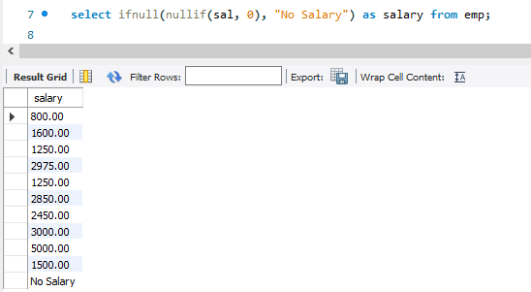

### ****Task 2 (16 Marks)****

1. Write query to display names of students as given in the figure. Join first two letters of the middle name with the last letter of the first name and * in between.

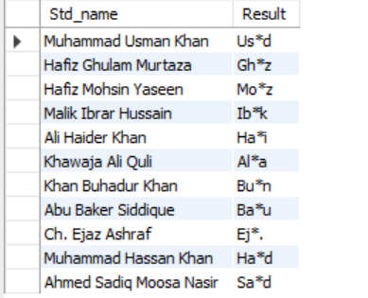

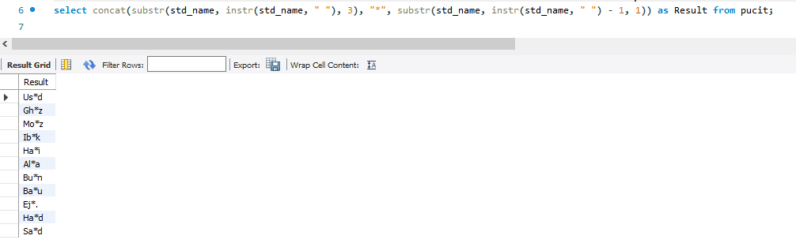

1. 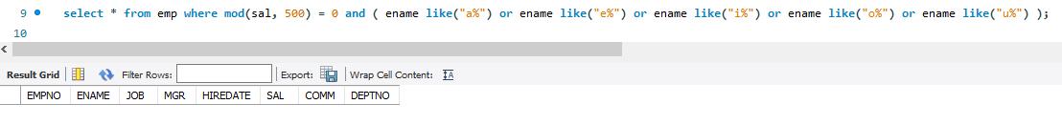Display Employees Who Have a Salary That Is a Multiple of 500 and their name starts with vowels
2. Retrieves the employee's name and salary, and generates a "salary bar" using dollar signs ($). For every 500 units of salary, one dollar sign is printed. For example, if an employee's salary is 500, one dollar sign is printed; if the salary is 1000, two dollar signs are printed; and if the salary is 1500, three dollar signs are printed, and so on. This visually represents the salary in increments of 500 using dollar signs.

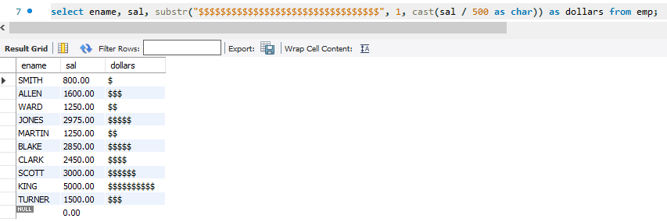

1. Employees Who Have the Same Letter “A” Multiple Times in Their Job Title

**Without using like operator.**

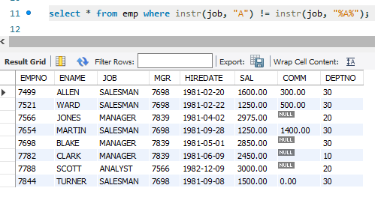

1. Retrieve Students from Pucit table having exactly two a’s in theirs name.

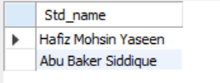

1. Display the employee code in the format XXX-YY-NN. The first 3 letters of the code are the last 3 letters of ENAME and YY is obtained from the last 2 digits of year in the HIREDATE. NN is the DEPTNO of the employee. Restrict the output to the employees working in DEPTNO 10 or 20 and their name starts with s.

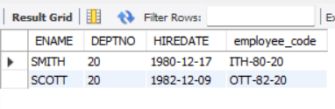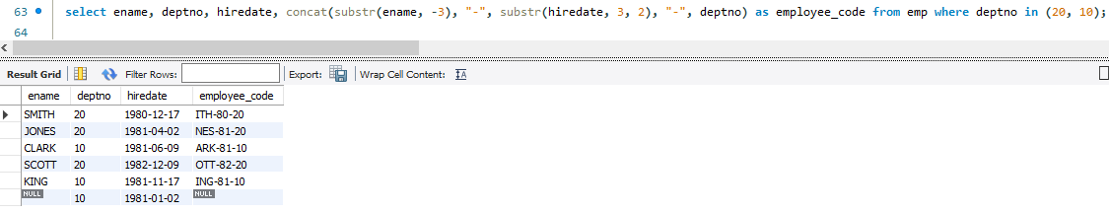

1. 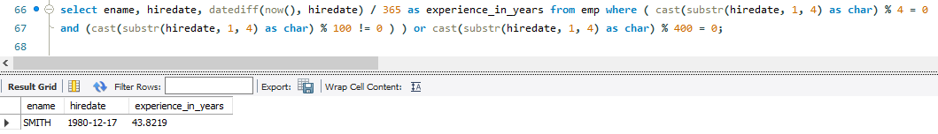Display the employees that are hired in leap years and their experience (experience expressed in years)
2. Find employees whose name contains 'L', extract the position of 'L' in their name, and concatenate the name with their job title. Format the hire date and check if their salary is NULL.

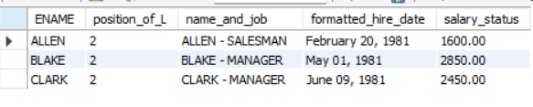

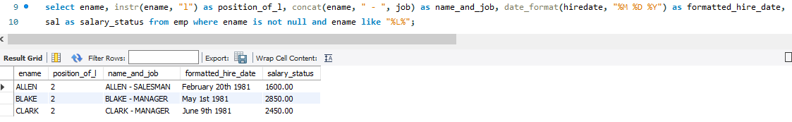

**Task 3 9 Marks**

1. Write a query to display introduction of each employee such as shown below.

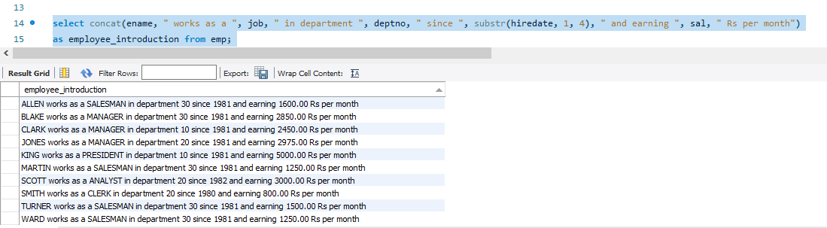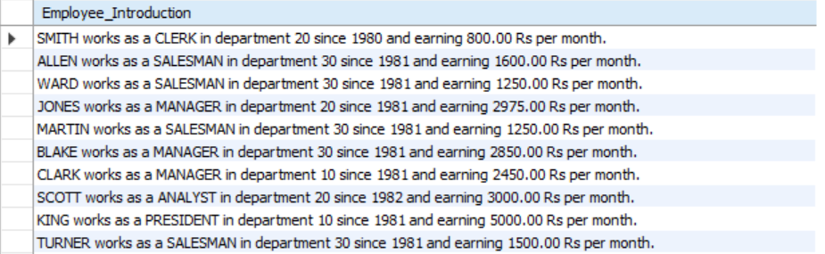

1. **Display employee names their original salary and comission. Increase their commission by 15% and salary by 20%. Show the overall (final) salary, which is the sum of the updated salary and updated commission.** Filter the results to show only those employees whose overall salary is between 2000 and 4000.

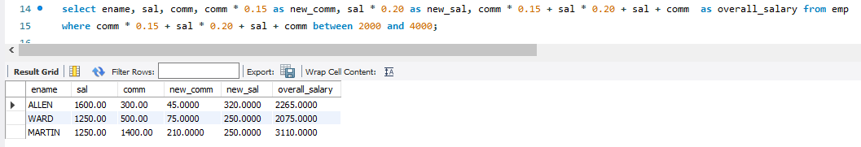

1. Removes the first character of the job title and appends it to the end. Appends -HIGH or -LOW based on the employee’s salary(2000) . Filters employees whose job title contains the letter "C". Excludes employees whose job titles contain the letters "N" or "A", **without using the LIKE operator.**

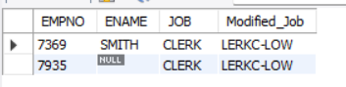

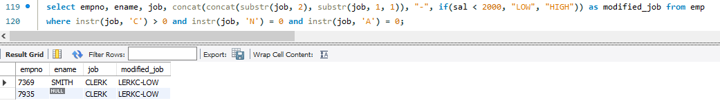

**VIVA VOCE 3 Marks**

* If instr("string_name”) is used, what will happen?

It will give error as instr() requires second parameter.

* If substr(“string_name”, 0) is used, will the code work?

It won’t work as string indexing in SQL starts from 1. If 1 is passed instead of 0, then the whole string will be returned.